**Scrum Excellence**

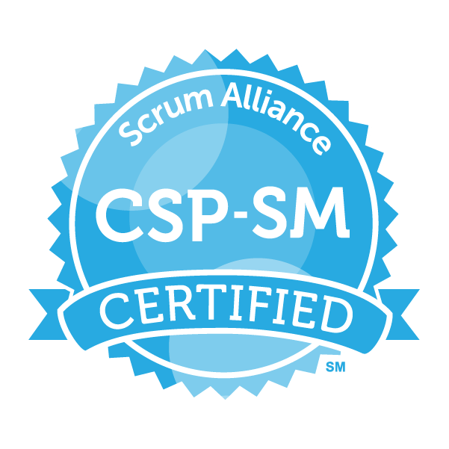

Sriram

# About Sriram



I have been involved in IT Software development since 1997. I have unique combination of process, technical and industrial skills. As a Digital Leader, I have expert level of knowledge in agile and practices with this combination I can help process and technology people, understand the agile world.

The “**Scrum Excellence”** book comprises of Scrum Framework. One in All, All in One & Key to Success.

My agile journey started in 2011, when I was a part of Tata Consultancy Services. I practiced scrum and agile methods thoroughly over several years and my teams are highly successful in delivering products using agile techniques.

I am proficient in agile engineering, coaching practices and SAFe consulting practices. I have more than 5 years of experience as a senior architect cum senior manager in development. I religiously follow key agile engineering practices like TDD, Refracting, CI and Collective Ownership. Worked in USA, UK for TCS, AtoS, Cognizant & IBM - Agile customers, which creates a global agile experience.

I moved back to India in 2016 and created agile websites and released books related to Scrum Alliance Professional, Agile Coaching and Implementing SAFe 5.0 practices.

Throughout my agile journey, I have been associated the agile professionals, who have helped and mentored me in the journey where sky is the limit.

Place: Dubai, UAE – Middle East Email: digitalcloudguru@gmail.com

B sriram

# Table of Contents

Contents

About Sriram 2

Table of Contents 3

Scrum Master 4

Introduction to Scrum 4

The Scrum Team 18

Scrum Artifacts 32

Scrum Events | Meetings 39

User Stories & Estimation 56

Release Planning 67

Agile Framework Comparison 70

Scrum Exercises 74

Scrum Games 94

Scrum Master Certifications Topics 98

# Scrum Master

## Introduction to Scrum

**What is Scrum?**

**“A framework within which people can address complex adaptive problems, while productively and creatively delivering products of the highest possible values.”**

* Scrum uses a methodology called the scrum framework & Scrum is a rugby term
* Scrum is light weight, easy to understand, but can be difficult to master, more flexible and allows other agile practices like XP to plug in
* The scrum framework is a set of practices, roles and responsibilities, events, artifacts, and rules

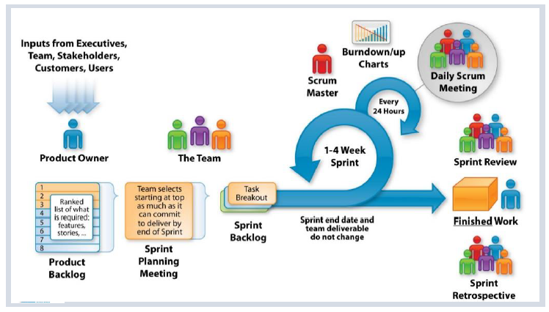

**Tell me Scrum in 100 words?**

* Scrum is an agile process that allows us to focus on delivering the highest business value in the shortest time.
* It allows us too rapidly and repeatedly and repeatedly inspect actual working software in every two weeks.
* The business set the priorities. Team self-organizes to determine the best way to deliver the highest priority features.
* Every two weeks to a month anyone can see the real working software and decide to release it as is or continue to enhance it for another sprint.

**What are the Characteristics of Scrum?**

* The most popular ‘Agile Processes’ in Agile software development & well suited for projects that require Empirical process control
* Focuses on self-organizing teams
* Requirements are captured in a prioritized list (Product Backlog)
* Product progresses in a series of month-long “sprints”
* No specific engineering practices prescribed
* Uses generative rules to create an agile environment for delivering projects

**What is Scrum theory?**

Scrum is based on empirical process control. It is not a set methodology but instead is a framework. Inspection, Transparency & Adaptation are the three pillars of Scrum.

**What are the Principles of Scrum?**

Scrum principles are the core guidelines for applying the Scrum framework and should mandatory be used in all Scrum projects.

The six Scrum principles are: -

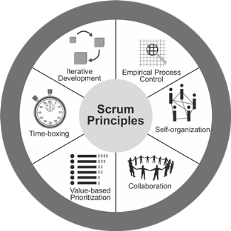

**Empirical Process Control:** This principle emphasizes the core philosophy of Scrum based on the three main ideas of transparency, inspection, and adaptation. Empirical process control aids learning through experimentation, especially when the problem is not well defined or when there are no clear solutions.

**Self-organization**: This principle focuses on today’s workers, who deliver significantly greater value when self-organized, and this results in better team buy-in and shared ownership; and an innovative and creative environment which is more conducive for growth.

**Collaboration:** This principle focuses on the three core dimensions related to collaborative work: awareness, articulation, and appropriation. It also advocates project delivery as a shared value-creation process with teams working and interacting together, as well as with the customer and other business stakeholders, to deliver the greatest value.

**Value Based Prioritization**: This principle highlights the focus of Scrum to deliver maximum business value, from early in the project and continuing throughout.

**Time-boxing**: This principle describes how time is considered a limiting constraint in Scrum and used to help effectively manage project planning and execution. Time-boxed elements in Scrum include Sprints, Daily Standup Meetings, Sprint Planning Meetings, Sprint Review Meetings, and Retrospect Sprint Meetings.

**Iterative Development**: This principle defines iterative development and emphasizes how to better manage changes and build products that satisfy customer needs. It also delineates the Product Owner’s and organization’s responsibilities related to iterative development.

**What are Defined & Empirical Process?**

**Defined Process**

**A Defined process defines all steps in advance, same output is expected every time the process is followed, best suits for “Simple” and “Complicated” problem domains.**

* Follows pre-defined steps to achieve an Output.
* Suitable when the output is well defined.
* Same output is expected every time the process is followed.
* Best suits for problems those fall into “Simple” and “Complicated” problem domains.

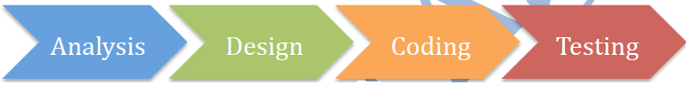

**Empirical Process**

**An Empirical process are interactive, incremental, change often, adapt, and pass through the reviews, Empirical processes are change-driven**

As software products and requirements cannot be 100% confirmed, fixed at the beginning, the best way to build the winning product is to continuously inspect, and adapt at regular intervals, effectively and efficiently. Empirical Process is based on such inspect and adapt cycle.



An Empirical Process is: -

* Built based on the series of experiments
* Experience based decision making
* Suitable when the output can’t be well defined
* Definition of output is refined based on the result of experiments
* Steps in the process are adjusted based on the feedback from the experiments
* Deming Wheel – Plan – DO Inspect -Adapt

In order to build the winning products and deliver value SCRUM has various feedback loops so that product and process are inspected, adapted and transparent.

**What are the Pillars of Scrum? What are the three legs of empirical process?**

Three legs of empirical process | pillars of SCRUM – Inspection, Adaptation & Transparency: -

* **Inspection** – Frequent Inspection of artefacts helps stakeholders to make any changes to achieve the goal i.e., Timely checks on how well a project is progressing toward goals & looks for problematic deviations or differences from goals
* **Adaptation** – Continuous improvement by adjusting the process based on the inspection i.e., Adjusting a process to minimize further issues if an inspection shows a problem or undesirable trend
* **Transparency**– All artefacts of the process are visible to all the stakeholders. This helps stakeholders to inspect the current stake and take any required action i.e., Visibility to those responsible for the outcome



**How would you say Scrum is based on empiricism?**

Scrum is based in empiricism because: -

* All Artifacts should be transparent to all stakeholders
* All Scrum roles are empowered to do the job right
* All Scrum meetings allow collaboration and opportunities for inspection ad adaptation
* In Scrum, the process is constantly adjusted if needed based on the short and continuous feedback loops at iteration levels

**How would you say Scrum is incremental and iterative?**

**Scrum team delivers value incrementally and iteratively**

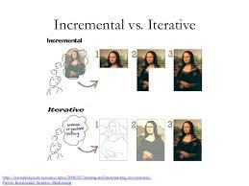

**Iterative Development**

Iterative development is to build something, to get some feedback, then refine it to make better, keep doing that until the product is good enough.

**Benefits**

* Focus on high value and good Return on Investment (ROI)
* Reduce rarely used features, maximize frequently used features
* Usable product at any time
* Quality Focus
* Effective and efficient
* Usable product at any time
* Sustainable pace of development

**Incremental Development**

Incremental development is to build small increment of a full fledges product. Each increment adds more software value – like Adding package to a Software Product. After lot of increments, you have got a big Software Product.

**Benefits**

* Reduce risk during development
* Early discovery and mitigation of risks
* Accommodates changes early
* Manageable Complexity
* Higher confidence and satisfaction from early repeated successful delivery
* Early and continuously visibility of product increment
* Better predictability and progress
* Higher quality and lower defects
* Final product close to customer’s desire
* Early and regular process improvement
* Continuous collaboration ad engagement with customers
* Effective and efficient
* Usable product at any time
* Sustainable pace of development

**Coin a Scrum Word from the Scrum values?**

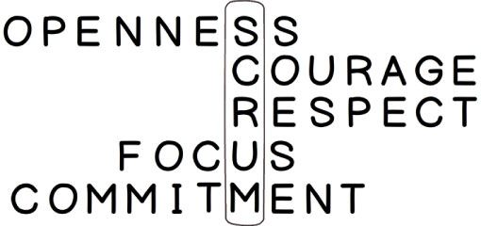

**What is the Project noise level in Agile? What is Ralph-Stacy Complex Model?**

Ralph-Stacy complexity model shows the different problem domains and their nature. The model has four problem domains namely Simple, Complicated, Complex & Anarchy | Chaotic.

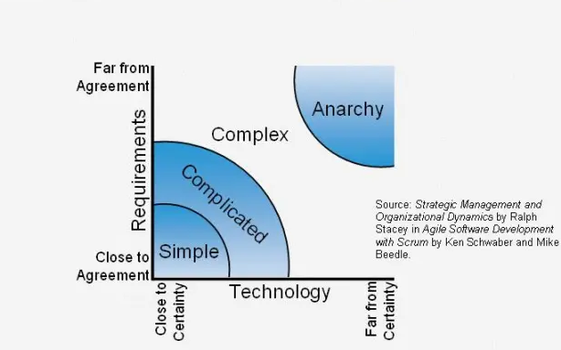

X- axis captures how something is being done. This represents the technology or implementation method. Y-axis shows what is being done. This represents requirements of the work being done.

**Problem Domains**

**Simple:** These problems are those we know what to do and how to do.

**Complicated:** These Problems require a specialized skill. Once you have an expert, they know how to do this.

**Complex:** There is no way to reduce uncertainty on what to do or how to do other than working iteratively. Scrum works best in this problem domain. i.e., Software Development

**Chaotic | Anarchy:** Problems in this region

**What are the Scrum Values?**

All work performed in SCRUM needs a set of values as the foundation for the team’s processes and interactions. And by embracing these five values, the team makes them more instrumental to its health and success.

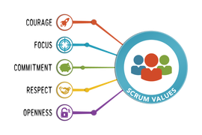

**Focus:** Because we focus on only a few things at a time, we work well together and produce excellent work. We deliver valuable items sooner.

**Courage:** Because we work as a team, we feel supported and have more resources at our disposal. This gives us the courage to undertake greater challenges.

**Openness:** As we work together, we express how we’re doing, what’s in our way, and our concerns so they can be addressed.

**Commitment:** Because we have great control over our own destiny, we are more committed to success.

**Respect:** As we work together, sharing successes and failures, we come to respect each other and to help each other become worthy of respect.

As an organization applies Scrum it discovers its benefits. At the same time, it sees how these values inherently contribute to the success of Scrum and understands why they are both needed, and bolstered, by Scrum.

**Scrum DOGMA | Rule**

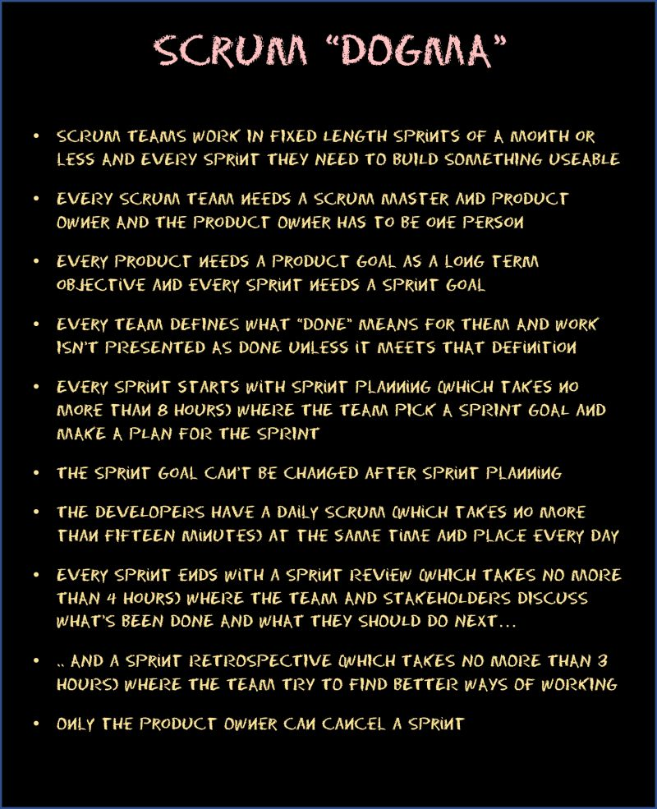

**Tell me about Scrum Framework in short?**

Already we have seen the Agile has 4 Values & 12 Principles.

SCRUM is a simple process framework. SCRUM has

**3 Legs**      : Inspect, Adapt, Transparent (Pillars of Scrum)

**3 Roles**      : Product Owner | Scrum Master | Development Team (The Scrum Team)

**3 Artifacts**  : Product Backlog | Sprint Backlog | Product Increment

**4 Meetings**  : Sprint Planning | Daily SCRUM | Sprint Review | Sprint Retrospective

**1 Activity**  : Product Backlog Refinement

**5 Values**     : Focus | Courage | Openness | Commitment | Respect

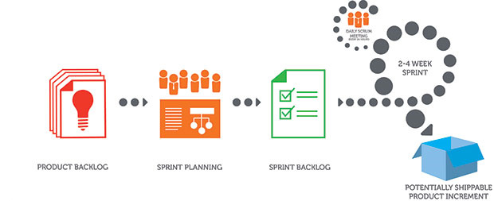

**Product Backlog -** Ordered list of items to be worked on for the product

**Sprint Backlog -** Product backlog items selected to work in the Sprint and the work plan to complete those items

**Product Increment -** Completed product backlog items in a sprint, which are ready to be delivered to the customer

**Product Backlog Refinement -**A meeting to get the product backlog items ready for the next few sprints

**Sprint Planning -** A meeting to create the sprint goal and plan the work for the sprint

**Daily Scrum -**A daily 15-minute time boxed event for the Development Team to synchronize activities and create a plan for the next 24 hours

**Sprint Review -**A meeting to inspect the product increment and adapt the product backlog if needed

**Sprint Retrospective -**A meeting for the scrum team to inspect and adapt the process, people and tools

## The Scrum Team

**Who are all the Scrum team member & What are the Roles & responsibilities?**

* **Scrum Master** –Responsible for communicating the scrum methodology and ensuring the methodology is used effectively
* **Product owner** –Prioritizes the product backlog to ensure value from each sprint
* **Development team** –The software developers who create the product through the sprint

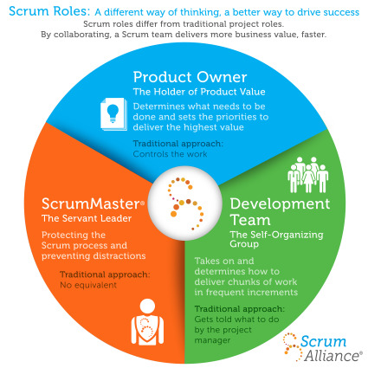

|  |  |  |  |
| --- | --- | --- | --- |
| **Item** | **Development Team** | **Product Owner** | **Scrum Master** |
| **Estimates** | * DT |  |  |
| **Backlog Priorities** |  | * PO |  |
| **Agile Coaching** |  |  | * SM |
| **Velocity Predictions** | * DT |  |  |
| **Definition of Done | Sprint Planning** | * DT | * PO | * SM |
| **Process Adherence** |  |  | * SM |
| **Technical Decision** | * DT |  |  |

**Product Owner**

* Product Owner owns the Product vision
* Defines features, decides on release date and content
* Responsible for market success
* Be responsible for the profitability of the product (ROI)
* Prioritize features according to the market value
* Adjust features and priority every iteration, as needed
* Accept or reject work results
* Maintains and grooms the Product Backlog
* An effective product owner is Committed, Responsible, Authorized, Collaborative, and Knowledgeable (CRACK)

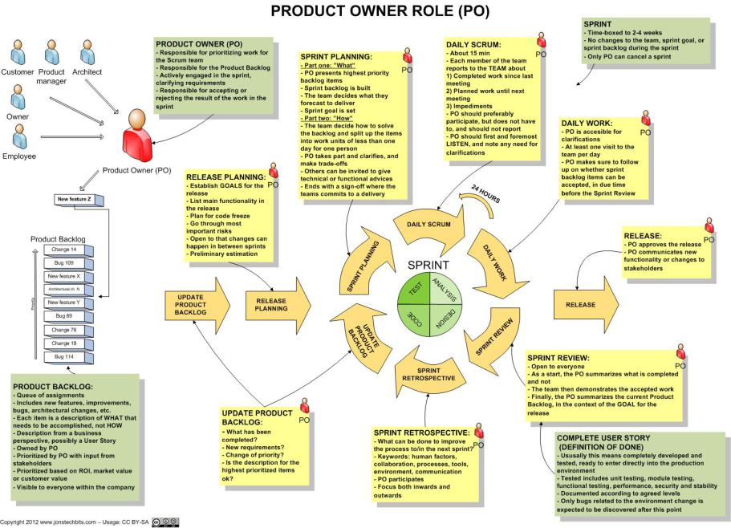

**Product Owner’s responsibility to Stakeholders**

Product owner collaborates with stakeholders of the product to understand their vision and market conditions and regularly update them on the progress of the product development. Product Owner

* Creates the Product vision if it does not exist
* Creates and manages Product Backlog to fulfil the Product vision
* Reviews the product with stakeholders in Sprint Review meetings to solicit feedback
* Updates stakeholders about progress of the product development typically every sprint
* Represents single voice of customers
* Prioritizes product backlog items based on business needs with the consensus of all stakeholders
* Orders the product backlog items to maximize the delivery value

**Product Owner responsibility to the team**

* Establishes the shared vision between stakeholders and the team
* Details out the product backlog items as appropriate. Make sure that high value items are ready for implementation in upcoming sprints
* Helps team estimate by clarifying any questions
* Available to the team to answer any questions regarding the product domain during the sprint
* Optimizes the value of the work the development team performs
* Keeps the product backlog transparent, clear and visible to all
* Attend Scrum Meetings
  + Sprint Planning: Helps the team plan to sprint
  + Sprint Review: Reviews the product increment with stakeholders
  + Sprint Retrospective: Contributes to come up with improvement ideas

**Other responsibilities of a Product Owner**

* Responsible for deciding whether to release the product increment at the end of the sprint
* Creates and manages the release plans
* Tracks the release progress

**Scrum Master**

* Responsible for facilitating process & represents management to the project
* Responsible for enacting Scrum rules, values and practices and censure team members and stakeholders not adhering to these rule’s ad norms
* Removes impediments
* Looks for ways to enhance productivity
* Assists Product Owner in leveraging Scrum
* Ensure that the team is fully functional and productive
* Enable close co-operation across all roles and functions
* Focuses Team, shield the team from external interferences
* Practices “Servant Leadership” – Facilitator and enabler rather than a manager

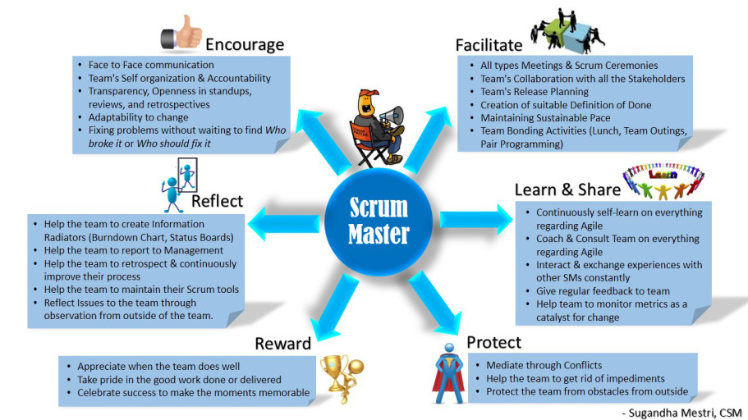

**General Responsibilities of Scrum Master**

* Teaches Scrum to the team and the rest of the organization
* Ensures that scrum is understood and enacted
* Facilitate all scrum meetings as needed and requested. Makes sure that meetings are happening the scrum team. Coaches the team on how to complete the tasks on time within the timebox for that meeting
* Responsible for building the product fast by eliminating the waste
* A Servant – Leader for the Scrum Team
* Act as a change agent that increases the productivity of the Scrum team

**Scrum Master Service to the Product Owner**

The Scrum Master serves the Product Owner in several ways, including: -

* Helps Product Owner to prioritize the work. Teaches PO and Stakeholders value- based prioritization
* Finding techniques for effective Product Backlog management;
* Helping the Scrum Team understand the need for clear and concise Product Backlog items;
* Understanding product planning in an empirical environment;
* Ensuring the Product Owner knows how to arrange the Product Backlog to maximize value;
* Understanding and practicing agility; and,
* Facilitating Scrum events as requested or needed.

**Scrum Master Service to the Development Team**

The Scrum Master serves the Development Team in several ways, including: -

* Identifies the impediments those are blocking the team to progress and help resolve them as quickly as possible. Scrum Master goal is to make sure the team is highly productive
* Coaching the Development Team in self-organization and cross-functionality;
* Helping the Development Team to create high-value products;
* Removing impediments to the Development Team’s progress;
* Facilitating Scrum events as requested or needed; and,
* Coaching the Development Team in organizational environments in which Scrum is not yet fully adopted and understood.

**Scrum Master Service to the Organization**

The Scrum Master serves the organization in several ways, including: -

* Assess the readiness of the organization to implement the team
* Leading and coaching the organization in its Scrum adoption;
* Planning Scrum implementations within the organization;
* Helping employees and stakeholders understand and enact Scrum and empirical product development;
* Causing change that increases the productivity of the Scrum Team; and,
* Working with other Scrum Masters to increase the effectiveness of the application of Scrum in the organization.

**What are the qualities of an effective Scrum Master?**

The Scrum Master to be effective, there various important skills to acquire. Here some of those skills are: - Facilitation | Coaching | Servant Leadership

**I - Facilitation**

Facilitation is the process of designing and conducting a successful meeting or event that has a particular objective. Facilitation serves the needs of any group, who are meeting with a common purpose. The person who facilitates the meeting is called a “Facilitator”



**Characteristics of Facilitator**

* Facilitator does not stand in front of the group and lecture
* Facilitator is an active unbiased member of the learning process
* Facilitator has to skillfully assist the group to understand their common objectives, and to help them to achieve these objectives without taking sides in any arguments
* Facilitator guides and helps to achieve consensus

Basic Skills of a Facilitator

* Follows a good meeting practice
* Time keeping
* Run the meeting on agenda
* Assisting the group to brainstorm and problem solve
* Ability to intervene in a way that adds creativity to a discussion rather than leading the discussion
* Ability to understand the group dynamics include:
* Who is dominating the group? How to stop him/her
* Who is withdrawn? How to involve him/her
* Who looks bored? How to get their attention

Good Facilitation techniques should: -

* Help the participants to be comfortable with each other
* Create a fun and interesting learning development
* Boost the energy levels of workshop participants
* Organize interesting and productive group work activities
* Use participatory activities which enable dynamic reviews of what has been learnt?
* Increase group activity so that workshop participants can expand on the new

**II - Coaching**

According to Tim Gallwey “Coaching is unlocking a person’s potential to maximize their own performance. It’s helping them to learn rather than teaching them”



Coaching is a useful way of developing people’s skills and abilities, and of boosting performance. It can also help deal with issues and challenges before they become major problems.

A coaching session will typically take place as a conversation between the coach and coachee (person being coached), and it focusses on helping the coachee discover answers for themselves

Occasionally, coaching may mean an informal relationship between two people, of whom one has more experience and expertise than the other and offers advice and guidance as latter learns.

**Qualities of a Coach**

* Coaches help to find solutions
* Coaching helps the organizations to change for the better
* Coaching is long term and sustainable results
* Coaching gives progressive elaboration
* Coaching helps you to review and refine your own solution to make it work

**Coaching is different from Consulting; the key differences are: -**

* Consultants usually identify and correct the problems. Coaches helps to find solutions
* Consulting is treated like a silver bullet where as Coaching helps the organizations to change for the better
* Consulting is often short term based and Coaching is long term and produce sustainable results
* Consulting may give sudden spike in improvement and Coaching gives progress elaboration
* Consulting is more of implanting some other’s solution but coaching helps you to review and refine your own solution to make it work

**How Scrum Master can become a good coach?**

* Develop positive attitude and patience
* Lead by example
* Keep up the balance
* Set the realistic pace
* Be cautious about your language
* Open to learn
* Accept feedback

**Compare Teaching Vs Mentoring Vs Coaching?**

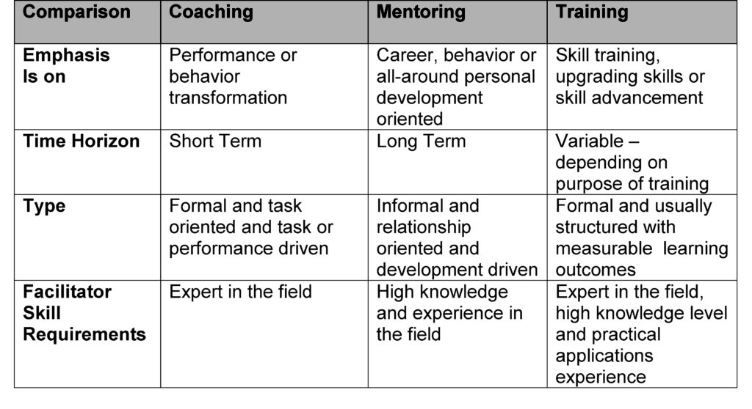

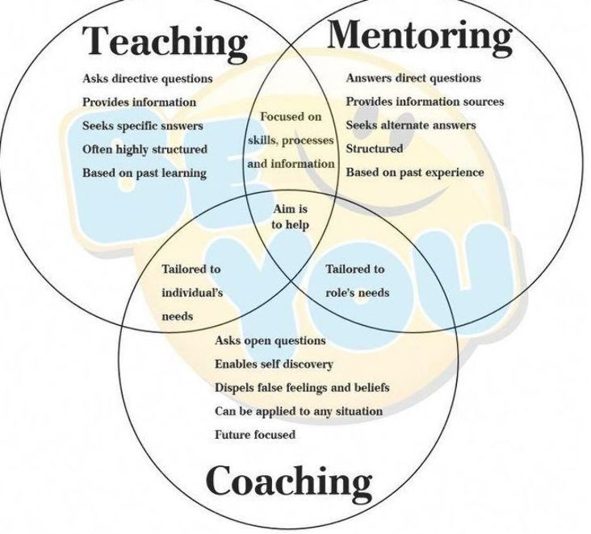

**III - Servant Leadership**

You must be the change you wish to see in the world. You are the change agent for your organization.

According to Robert K Greenleaf. The Servant-leader is servant first… it begins with the natural feeling that one wants to serve, to serve first. The conscious choice brings one to aspire to lead. That person is sharply different from one who is leader first, perhaps because of the need to assuage an unusual power drive or to acquire material possessions. The leader-first and servant-first are two extreme types. Between them there are shadings and blends that are part of the infinite variety of human nature.



On character and Servant Leadership

* Listening
* Empathy
* Healing
* Awareness
* Persuasion
* Conceptualization
* Foresight
* Stewardship
* Commitment to the growth of people
* Building community

**The Development Team**

* Small group containing all necessary project skills
* Typically, 4 – 9 people. Ideally 7+/- 2 (Note: Scrum Master & Product Owner Excluded)
* **Cross functional** – Programmers, testers, Architects user experience designers, etc.,
* Members should be full-time – May be exceptions for DBA’s
* Teams are **self-organizing** (No titles), Manages own work within Sprints
* Membership should change only between sprints
* Focuses on steady delivery of high-quality features
* Generates options for delivery
* Team has **common goal**. Individual Development Team members may have specialized skills and areas of focus, but accountability belongs to the Development Team as a whole.

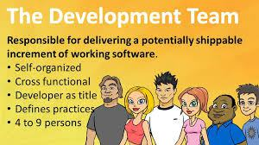

Team’s responsibilities include but not limited to:

* Quality of the product increment
* Create the product increment
* Participate in all scrum meetings
* Implement good engineering practices like Continuous Integration, Continuous Delivery, Automation, Collective Ownership, Clean code, Simple design & effectively run the Test-Driven Development & Behavior Driven Development
* Create and manage the product backlog
* Identify and eliminate the “Technical Debt”
* Track progress of the sprint
* Helps the product owner in backlog management by explaining technical constraints
* Estimates Product Backlog items

## Scrum Artifacts

**What are Scrum Artifacts?**

Scrum’s artifacts represent work or value to provide transparency and opportunities for inspection and adaptation. Artifacts defined by Scrum are specifically designed to maximize transparency of key information so that everybody has the same understanding of the artifact.

The core Scrum Artifacts are: -

* Product Backlog
* Sprint Backlog

**Product Vision**

A product vision is created by the product owner. The product must be in alignment with the company’s strategy that describes the business vision. It gives a view to all involved about why the work is being undertaken and what to expect from it.

**Product Roadmap**

Product Roadmap is a pictorial representation of which product features would be delivered in which release. It is created during the strategy meeting. The product roadmap equates to the product division as a whole. This is done and owned by the product owner.



**Product Backlog**

* An ordered list of all items that might be needed in the product
* Single source of requirements for any changes to be made to the product
* The Product Owner is responsible for the Product Backlog, including its content, availability and ordering. Items in the Product Backlog are called “Product Backlog Items (PBI)”
* Each product backlog item would have:
  + Description – Details of the item
  + Value – What business value this item would provide
  + Estimate – Effort estimates to build this item
  + Order – The order in which the items should be worked in

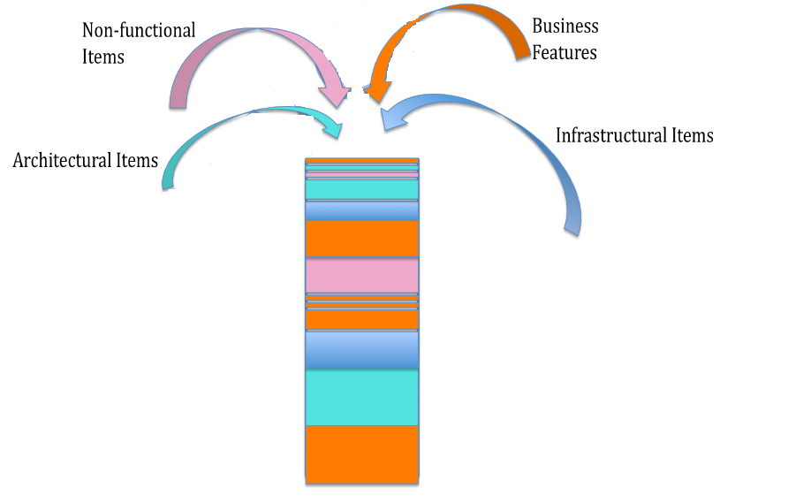

* The product owner sorts and prioritizes the backlog items
* The development team always works on the most important items based on the prioritized items in the product backlog
* The backlog is always prioritized before the current sprint
* Backlog refinement is done by both the product owner and the development team working in harmony is called grooming or refinement of backlog
* The team estimates their capacity to attack the items in the product backlog
* A Product Backlog is best described as **DEEP**
  + **D**etailed Appropriately: Higher order items are more detailed and well understood compared to lower order items
  + **Estimated:** Product backlog items are estimated i relative size by the development team. Product owner orders the items based on the value and the cost
  + **Emergent:** Product Backlog is a living artifact. It is always updated for details, estimates and order. The life of the product backlog is same as life of the product itself
  + **Prioritized:** Product backlog items are ordered based on the priority. The order is force ranking (1,2,3) so that there are no completing priorities
* To determine the **Priority**

Customervalue prioritization is concerned with working on the items that yield the highest value to the customer as soon as possible.

**MoSCoW** is a technique used to prioritize stories into four distinct categories:

* **M – MUST** have this  
  Requirements that are fundamental to the system; without which system will not work and have no value and have to be included in the current delivery time box
* **S – SHOULD** have this  
  Requirements that is important for project success; Important as MUST have but not as time-critical or have a work around. In other words, not necessary for delivery in the current delivery time box
* **C – COULD** have this  
  Requirements not necessary; can include if it increases customer satisfaction for little development cost
* **W – WON’T** have this time, but WOULD like in the future  
  Alternatively WANT – No to this release

**Release Backlog**

It is created during the Release Planning Meeting and includes only those user stories that are to be delivered in that release, it is a subset of the Product Backlog.

**Sprint Backlog**

It is a subset of Release backlog and contains only those user stories that are targeted to be delivered in the particular sprint. It is also accomplished by a plan for the sprint. This is created during Sprint Planning Meeting.

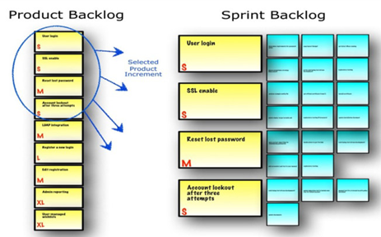

* Highest priority items take into the sprint for implementation and the plan to deliver those items is sprint backlog
* Sprint backlog is created during sprint planning
* Helps team see the total work involved in achieving the sprint goal
* Development team creates and manages the sprint backlog, this includes updating the time left of each task, create any forgotten tasks, update the status of each task etc.
* Team should keep the status of the items up to date so that the sprint progress is transparent
* All items should be updated at least once a day
* Team uses Daily Scrum meeting to inspect and adapt the Sprint backlog

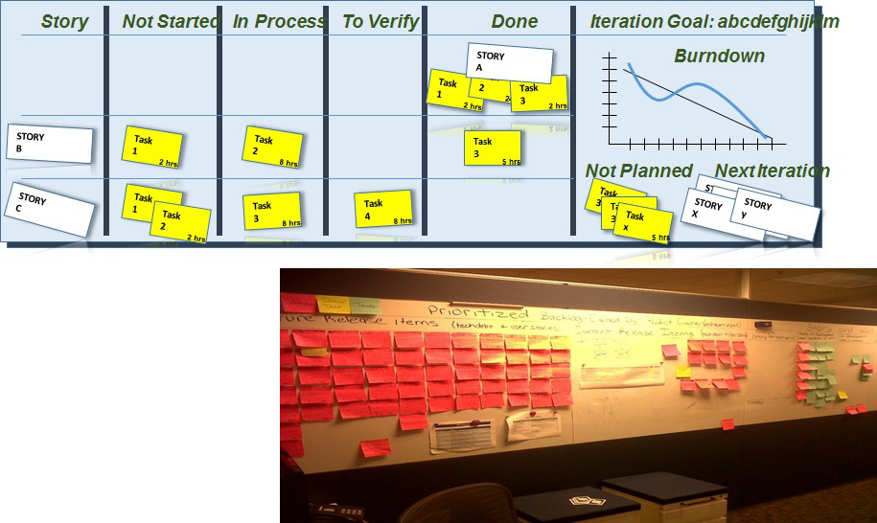

**Product Backlog Refinement**

Product backlog refinement is the process through which product backlog items are reviewed by the Scrum team and revised, providing more detail and ensuring that there is greater clarity in the requirements for that item.

When product backlog is initially created it would have items of various sizes, clarity and value. But a scrum team needs clarity on few most important to get started. Backlog could be depicted as the following picture. Items at the top are important right now and should be smaller in size and more details so that team could start implementing them in upcoming sprints. As you go lower the product backlog, the items are less important ad less detailed. Product owner elaborates them as they become important.

Scrum has an activity called “Product Backlog Refinement” to progressively elaborate the product backlog.

* Primary goal of product backlog refinement is to get ready with few items for upcoming one or two sprints
* Product Backlog items that are refined are deemed “Ready” for selection in a Sprint Planning
* Product Backlog Refinement is the act of adding detail, estimates and order to items in the Product Backlog
* Product Backlog Refinement is an ongoing activity throughout a Scrum project
* Team and PO decide the frequency and duration of backlog refinement meeting. However, it is time boxed at 10% of total available time.

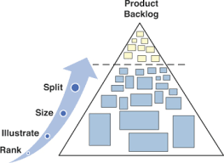

**Product Increment**



Input: Product Backlog Item | Output: Updated Product Backlog

**Should the team always release the Product Increment?**

At the end of each sprint, the team must produce a potentially shippable product increment with the following features

* + High Quality
  + Tested
  + Completed
  + Ready to Use
  + As per Definition of Done
* It depends. If the product increment that is produced is usable and adds the value to the business, product owner may choose to release it right away.
* Though the product increment is working, it may not be the feature complete and product owner may not want to release it
* Some business doesn’t want to surprise their customers too often by frequent release
* Whether the product increment is shipped or not, building working software every sprint eliminates the technical uncertainty

## Scrum Events | Meetings

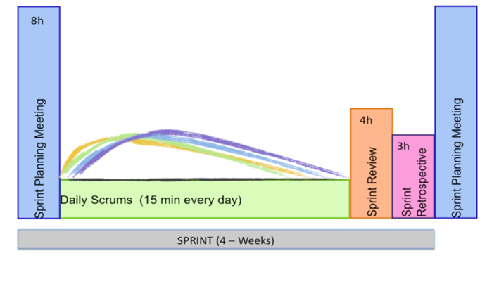

Prescribed events are used in Scrum to create regularity and to minimize the need for meetings not defined in Scrum. All events are time-boxed events, such that every event has a maximum duration. Once a Sprint begins, its duration is fixed and cannot be shortened or lengthened. The remaining events may end whenever the purpose of the event is achieved, ensuring an appropriate amount of time is spent without allowing waste in the process.

Other than the Sprint itself, which is a container for all other events, each event in Scrum is a formal opportunity to inspect and adapt something. These events are specifically designed to enable critical transparency and inspection. Failure to include any of these events results in reduced transparency and is a lost opportunity to inspect and adapt. Scrum activities are also known as events or ceremonies

The major scrum events or ceremonies:

* + Sprint planning
  + The Sprint
  + Daily scrum
  + Sprint reviews
  + Sprint retrospective

**Timeboxing**

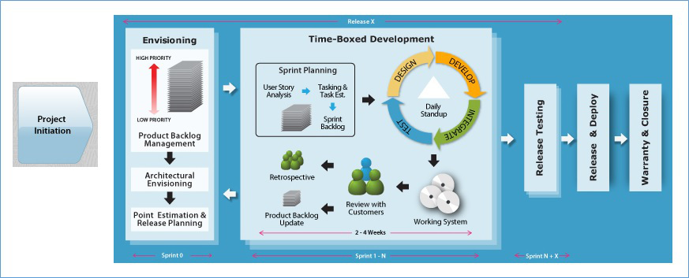

* + Time boxing is the maximum time allowed for an event
  + Time boxing makes tams focus on most important things first
  + All Scrum events are time boxed. Sprints are time boxed @ 1 to 4 weeks
  + Other Scrum events are time boxed based on the sprint duration
  + All official Scrum Events use the agile concept of Timeboxing.
  + The SM ensures the events are kept within the timebox.
  + Timeboxing helps the members of the Scrum Team™ stay focused on the same objective.
* As a result, the members who work on a problem are encouraged to come up with the best solution in the time allotted
  + Timeboxing limits the work in progress.

Extending a Sprint for a few more days to achieve the Sprint Goal is not allowed

**Sprint Planning**

The purpose of sprint planning meeting is to determine what the work will be done in that sprint and how the work will be achieved.

|  |  |
| --- | --- |
| **Who Attend?** | Dev Team, Product Owner and Scrum Master |
| **When?** | First day of the Sprint |
| **Time box** | 4 hours for 2 weeks Sprint | 8 hours for 4 weeks Sprint |
| **What?** | * Discuss Sprint Backlog * What to do? – Product Owner * How to do? – Development Team |
| **Input** | * Refined Product Backlog * Latest product increment * Projected team’s capacity * Team’s prior performance |
| **Outcome** | Sprint Backlog & Sprint Goal |

**How the Sprint Planning meeting gets executed?**

* Product Owner and Project team needs to discuss the goals of the upcoming sprint
* Product Owner and team negotiates stories to select in current sprint from prioritized product backlog for the upcoming sprint
* Selected stories are estimated with agreed acceptance criteria
* Team identifies and estimates Task, discusses how the work will be accomplished
* Scrum Master, Product Owner and team can attend the meeting
* Product Backlog has to be groomed by PO prior to sprint planning meeting, Product owner reviews with the team items in the updated backlog
* Self-organized Development team defines how the work will be done in the goals of the sprint will be achieved
* Normally split into 2 sets of 4 hours each Timebox: Max 8 hours per sprint
* First half for choosing the product backlog items with PO
* Second half for splitting into tasks and assignment (Product Owner is optional for the second half)
* The development team predicts what can be delivered based on estimates, projected capacity, and past performance to define the sprint goal.
* The development team then determines how this functionality will be built and how the team will organize to deliver the sprint goal.
* Output of this will be the sprint backlog. The work to get done in the next sprint.
* Artifacts – Sprint Goal, Sprint Backlog (Output of Sprint Planning)

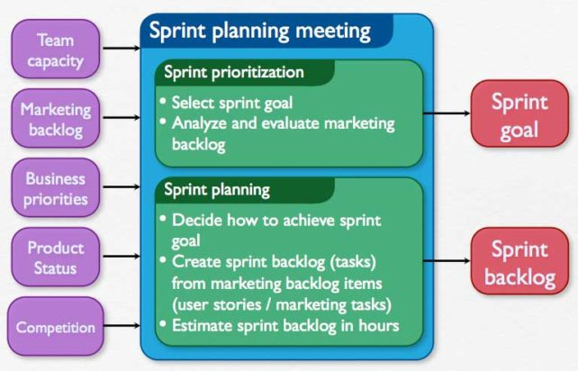

**Input:** Refined Product Backlog | Latest Product Increment | Team Capacity

**Outcome:** Sprint Goal | Sprint Backlog

**Sprint Goal**

The Sprint Goal is an objective set for the Sprint that can be met through the implementation of Product Backlog.

It provides guidance to the Development Team on why it is building the Increment. It is created during the Sprint Planning meeting. The Sprint Goal gives the Development Team some flexibility regarding the functionality implemented within the Sprint. The selected Product Backlog items deliver one coherent function, which can be the Sprint Goal. The Sprint Goal can be any other coherence that causes the Development Team to work together rather than on separate initiatives.

As the Development Team works, it keeps the Sprint Goal in mind. In order to satisfy the Sprint Goal, it implements the functionality and technology. If the work turns out to be different than the Development Team expected, they collaborate with the Product Owner to negotiate the scope of Sprint Backlog within the Sprint.

**Sprint Cancellation**



A Sprint can be cancelled before the Sprint time-box is over. Only the Product Owner has the authority to cancel the Sprint, although he or she may do so under influence from the stakeholders, the Development Team, or the Scrum Master.

A Sprint would be cancelled if the Sprint Goal becomes obsolete.

This might occur if the company changes direction or if market or technology conditions change. In general, a Sprint should be cancelled if it no longer makes sense given the circumstances. But, due to the short duration of Sprints, cancellation rarely makes sense.

When a Sprint is cancelled, any completed and “Done” Product Backlog items are reviewed. If part of the work is potentially releasable, the Product Owner typically accepts it. All incomplete Product Backlog Items are re-estimated and put back on the Product Backlog.

The work done on them depreciates quickly and must be frequently re-estimated. Sprint cancellations consume resources, since everyone has to regroup in another Sprint Planning to start another Sprint. Sprint cancellations are often traumatic to the Scrum Team, and are very uncommon.

**The Sprint**

The heart of the Scrum is Sprint. A sprint is a timeboxed(time-limited) iteration of 1 - 4 weeks to build a potentially releasable product.

Each sprints contain and consists of the following: -

* Sprint Planning
* Daily Scrums
* Development work
* Sprint Review
* Sprint Retrospective

Sprints best have consistent durations throughout a development effort. A new Sprint starts immediately after the conclusion of the previous Sprint.

During the sprint, no changes are made that would affect the sprint. The development team members are kept the same throughout the sprint

The development team works on one item at a time to completely build it such that each item could be usable and releasable. Team does all the functions required to complete each item.

**Sprint is protected**

During the Sprint: -

* No changes are made that would endanger the Sprint Goal;
* Quality goals do not decrease; and,
* Scope may be clarified and re-negotiated between the Product Owner and Development Team as more is learned.

Each Sprint may be considered a project with no more than a one-month horizon. Like projects, Sprints are used to accomplish something. Each Sprint has a definition of what is to be built, a design and flexible plan that will guide building it, the work, and the resultant product.

Sprints are limited to one calendar month. When a Sprint’s horizon is too long the definition of what is being built may change, complexity may rise, and risk may increase. Sprints enable predictability by ensuring inspection and adaptation of progress toward a Sprint Goal at least every calendar month. Sprints also limit risk to one calendar month of cost.

**Architecture is built incrementally**

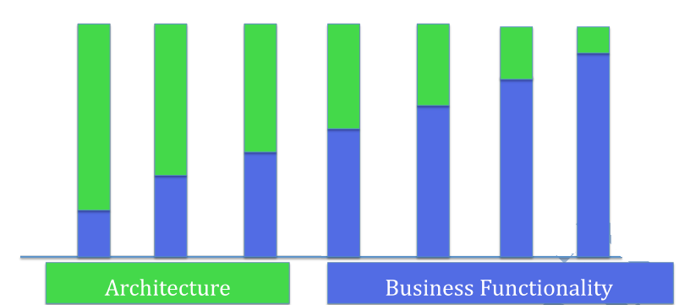

**Test small test often**

* Testers are involved right from the beginning
* Developers check in code in smaller testable chunks
* Testers try the functionality to see its working
* Testers and developers collaborate throughout the sprint
* The goal is to deliver usable product increment at the end of every sprint

**What else happens in a Sprint?**

* DBA’s, sysadmin, Technical Writers and any other supporting members are involved ASAP. Data models and database design done incrementally
* Documentation evolves as the stories are implemented
* Executable test document the test cases

**Iteration**

* Sprint and iteration are essentially the same things. The standard duration for each is two weeks.
* Iteration is a small amount of time (1 to 4 weeks) used to build a small part of the product
* Iteration planning meetings have two parts that are time-boxed

**Part 1 – What**

* Product Owner explains the items at the upper part of the Product Backlog
* Team estimates how much they can take on in an iteration
* Team makes a preliminary commitment

**Part 2 – How**

* Team Plans how they are going to implement their commitment
* Team starts with design, and this leads to a list of tasks (Iteration Backlog)
* Team confirms their commitment (or adjust it)

**Iteration 0**

Iteration 0 is conducted at the start of every release to: -

* (Re) Validate the core and extended team members
* Identify all dependent group signoff need
* Identify the development and test environment
* Identify the dependencies on other projects, teams & resource that may influence the release schedule
* Identify the deliverables and signoff needed
* Identify number of iterations for the release using team velocity (if any)
* Identify the schedule for release testing and release iteration | sprint. As a guideline, have release iteration after every three-time boxed developed iterations
* Identify any assumptions made
* Identify the risks involved in the project
* Detail the project | release schedule
* Create a release plan

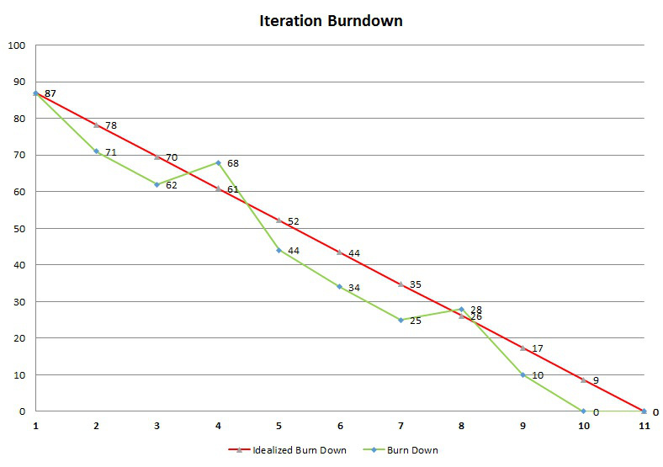

**Daily Scrum**

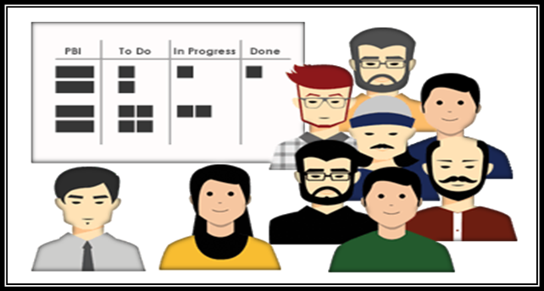

|  |  |
| --- | --- |
| **Who Attend?** | Dev Team and Scrum Master |
| **When?** | Entire Sprint duration |
| **Time box** | Max 15 Mins |
| **What?** | * What did you do yesterday? * What will you do today? * Are there any impediments in your way? |
| **Input** | Sprint Backlog & Sprint Goal |
| **Outcome** | * Plan for next 24 hours * List of impediments if any |

* The purpose of the daily scrum meeting is for development team to sync up, team will inspect and adapt the sprint backlog.
* A 15-minute time-boxed activity for the Development Team to synchronize activities and create a plan for the next 24 hours
* Should be held at the same time and place each day
* Scrum master makes teaches the team how to stick to the time box, make sure that the meeting is happening and facilitates if needed
* Development team member gets together and answer 3 questions:
* What did you do yesterday?
* What will you do today?
* Are there any impediments in your way?

**Sprint Review**



|  |  |
| --- | --- |
| **Who Attend?** | Product Owner, Dev Team and Scrum Master |
| **When?** | Last day of the Sprint |
| **Time box** | 2 hours for 2 weeks sprint | 4 hours for 4 weeks sprint |
| **What?** | Review Product Increment & give feedback. Feedback goes to the Product Backlog |
| **Input** | Product Increment, Product Backlog & Market Conditions |
| **Outcome** | * Feedback on Product * Updated Product Backlog * Direction for the Product Backlog |

* The purpose of the Sprint Review meeting is to inspect and adapt the product itself.
* Should be time boxed to no more than an hour per week of Sprint
* Product Owner invites few key stakeholders, Scrum Master make sure that the meeting is happening and teaches the team on how to complete it with in the time box
* Takes place at the end of the Sprint
* Development Team demonstrates the product increment built during the sprint
* Development Team talks about any impediments they have to work through while building the product
* Designed to gather feedback from stakeholders on what the Team has completed in the sprint, Stakeholders talks about the market conditions, future direction etc.,
* Product Owner presents the product backlog as it is and discusses what is done and what is not
* To create a conversation between the Team and the stakeholders about how to make the product better
* Product Owner updates Product Backlog based on the new learning

**Sprint Retrospective**



|  |  |
| --- | --- |
| **Who Attend?** | Product Owner, Dev Team and Scrum Master |
| **When?** | Last day of the Sprint |
| **Time box** | 3 hours for 4 weeks sprint |
| **What?** | * What went well? * What did not went well? * Any improvement – Identify the improvement list |
| **Input** | * Feedback |Experiences in the sprint * Current Practices |
| **Outcome** | Prioritized list improvements |

* The purpose of the sprint retrospective meeting is to inspect and adapt the process, practices, tools and behaviors of Scrum team members.
* Scrum master attends the accountability standpoint as well as helps the team complete the meeting within the time box
* Opportunity for the Team to inspect and create a plan for improvements to be done during the next Sprint.
* Team discusses: -
* What went well?
* What went wrong?
* What are the improvements? | What to do more of?

**The Definition of Done**

* Definition of Done is a list of attractive activities agreed by the Product Owner and the Development Team to call a backlog item is done during the sprint.
* Definition of Done consist of activities needed for functional and quality requirements
* Team comes up with the DOD and adheres to it while creating the product increment
* Different teams may have different DOD but all teams should follow minimal DOD that includes all critical activities required
* If there are standards at organizational level, a common DOD can capture those and the teams should have separate DOD in addition to one at the organizational level

A stronger DOD leads to higher quality product: -

* Code Complete
* Unit tests Written
* Code Review
* Manual Functional Testing
* Automation
* Updated Documents
* User Acceptance Testing
* Successful Deployment
* Suppose if the DOD is missing essential activities, it is called a Weak DOD. For E.g. Load testing may not be done for every sprint and is deferred to later time.
* A weak DOD causes unfinished work in every sprint. The unfinished work is added back to product backlog. This increased the risk. If a major bug is found during the load testing, that could risk the release
* Weak DOD also increases the Technical Debt. This might include the automation or code reviews

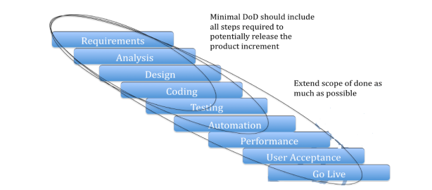

**Scrum Meetings Comparison**

|  |  |  |  |
| --- | --- | --- | --- |
| 1. Sprint Planning | | 2. Daily Scrum | |
| Who | Product Owner, Dev Team | Who | Dev Team |
| When | First day of Sprint | **When** | Entire Sprint duration |
| Time box | Max 8 hours | **Time box** | Max 15 Mins |
| What | * Sprint Back log  * What to do? – Product Owner  * How to do? – Team | **What** | * What did you do yesterday?  * What will you do today?  * Are there any impediments in your way? |
| Input | Prioritize Product Backlog | **Input** | Sprint Backlog |
| Outcome | Sprint Goal, Sprint Backlog | **Outcome** | Updated Sprint Backlog |
|  |  |  |  |
| 3. Sprint Review | | **4. Sprint Retrospective** | |
| Who | Stakeholders, Product Owner, Scrum Master | Who | Scrum Master, Product Owner, Team |
| When | Last day of Sprint | **When** | End of Sprint |
| Time box | Max 4 hours for 4 weeks | **Time box** | Max 3 hours |
| What | Review Product Increment & give feedback, feedback goes to product backlog | **What** | * What went well  * What did not went well  * Any Improvements  * Identify the improvements list |
| Input | Product Increment | **Input** | Feedback / Experience of team members |
| Outcome | Product Backlog (Revised) | **Outcome** | List of Improvements |

## User Stories & Estimation

**User Stories**

**What is User Story?**

User stories are well suited as product backlog items. User story is not a concept from Scrum but commonly used in Scrum projects to manage requirements.

User Story is as any user, I want to create my account: -

* Token for the feature
* Usually written on a small index card
* Captures intent of the failure
* Captures conditions of satisfaction or acceptance test criteria

**User story is written in which format?**

As a <who> I want to <what> So that < why>

Who: User of the product

What: Activity user wants to perform using the feature

Why: Purpose the feature is going to serve.

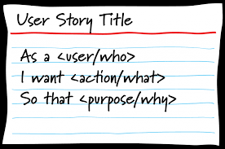

**What 3C’s of User story?**

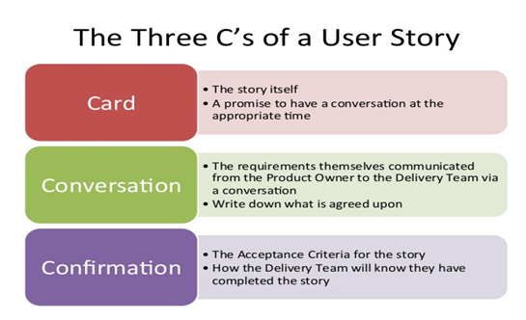

**Acceptance Criteria of User Story?**

Acceptance Criteria is the criteria if the product satisfies the user story is considered done. Acceptance Criteria is basis for high level test cases.

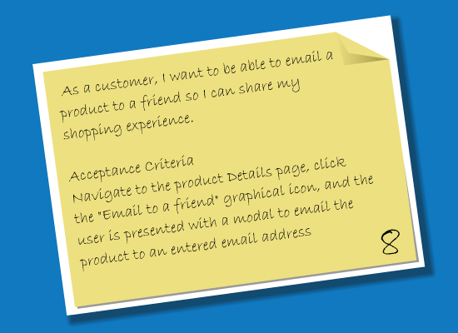

**How to write good user stories?**

It is essential to write user stories, which are small and independent enough to be worked on in each sprint. For a good product backlog, the team should INVEST in good user stories:

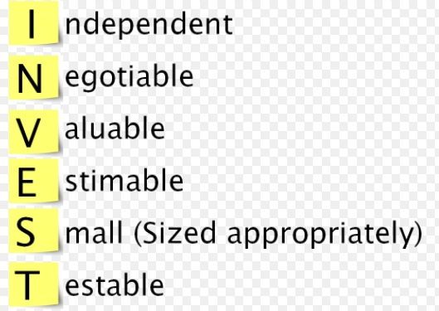

**Independent:** Stories should be independent enough so that the team does not have to pull in many other stories along with that story.

**Negotiable:** Team should be able to negotiate stories in and out of a sprint. This way the team can maximize the value.

**Valuable:** Valuable to the customer directly or indirectly. A technical story may not add a direct value to the customer.

**Estimable:** Team should be able to estimate the stories. This requires clarity on detail and the stories are independent.

**Sized Appropriately:** Higher order stories are smaller in size such that they could be completed in a sprint

**Testable:** A story should cover one piece of functionality that could be tested in isolation

**How to split the User Story?**

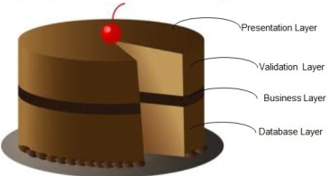

**Estimation: Planning Poker Game**

During Agile estimation, use poker card to raise the points as per the baseline.

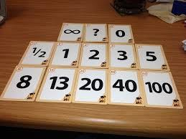

Planning Poker® is a consensus-based estimating technique. Agile teams around the world use Planning Poker to estimate their product backlogs. Planning Poker can be used with story points, ideal days, or any other estimating unit.

Planning Poker is an agile estimating and planning technique that is consensus based. To start a poker planning session, the product owner or customer reads an agile user story or describes a feature to the estimators.

Each estimator is holding a deck of Planning Poker cards with values like 0, 1, 2, 3, 5, 8, 13, 20, 40 and 100, which is the sequence we recommend. The values represent the number of story points, ideal days, or other units in which the team estimates.

The estimators discuss the feature, asking questions of the product owner as needed. When the feature has been fully discussed, each estimator privately selects one card to represent his or her estimate. All cards are then revealed at the same time.

If all estimators selected the same value, that becomes the estimate. If not, the estimators discuss their estimates. The high and low estimators should especially share their reasons. After further discussion, each estimator reselects an estimate card, and all cards are again revealed at the same time.

The poker planning process is repeated until consensus is achieved or until the estimators decide that agile estimating and planning of a particular item needs to be deferred until additional information can be acquired.

**Estimate the Painting Project**

|  |  |
| --- | --- |
| Master Bedroom 20 Ft * 16 Ft – Walk in Close (1/8) | 20 |
| Store Room – 4 Ft * 6 Ft | 2 |
| Kid’s Bedroom – 12 Ft * 12 Ft | 13 |
| Guest Bedroom – 10 Ft * 10 Ft | 8 |
| Study Room – 10 Ft * 10 Ft – Book Shelves | 8 |
| Living Room – 14 Ft * 14 Ft | 13 |
| Family Room – 20 Ft * 18 Ft – High Ceiling | 40 |
| Foyer – 6 Ft * 12 Ft | 5 |
| Servant Room – With Bathroom | 8 |
| Exterior Painting | 40 |

**Agile Estimation**

Product backlog items are estimated so that the product owner can make trade off decisions in prioritizing the items. Estimates are also required for release or long-term planning. In scrum, the product backlog items are progressively elaborated, so estimating them in hours is very difficult.

|  |  |  |
| --- | --- | --- |
|  | Problem | Solution |
|  | (Product Backlog Items) | (Tasks) |
| Who | Development Team | Development Team |
| When | Product Backlog Refinement | Sprint Planning |
| Unit of Measure | Story Points, Function Points, Use Case Point, Ideal Days, etc., | Hours |
| How | Planning Poker, Delphi, PERT, COCOMO, Expert Judgement, etc., | Expert Judgement |

**How estimation different in Scrum? Why do we need estimates?**

**Estimates are relative sizes**

* Humans are good at estimating by comparison
* Backlog items are estimated in relative sizes
  + Size 4 item is roughly two times bigger than size 2 item
* Size represents the relative effort it takes to complete the item
  + Size 4 item takes two time longer than size 2 item
* Estimates are influenced by
  + How much is there?
  + How hard is it?
* Estimates are at the right granularity
  + Estimates should be roughly accurate than precisely wrong

**Common units of estimation using Story Points**

Indicates how big is an item?

A 4-point item is two times bigger than 2-point item

Unit less

**How long it will take in days (Ideal days) if?**

It’s all you worked on

No interruptions

No impediments

**Advantages of Story Points**

Story points are additive, time-based estimates may not be

Story points avoids unit confusion

|  |  |
| --- | --- |
| **Estimate the cement plastering / painting project**  First baseline one area and arrive other area | |
| **Area** | **Story Points** |
| Master Bed Room 20 ft * 16 ft – Walk in closet (1/8) | **20** |
| Store Room – 4 ft * 6 ft – (**Baselined**) | **2** |
| Kid’s Bed Room – 12 ft * 12 ft | **13** |
| Guest Bed Room – 10 ft * 10 ft | **8** |
| Study Room – 10 ft * 10 ft with Book Shelves | **8** |
| Living Room – 14 ft * 14 ft | **13** |
| Family Room – 20 ft * 18 ft with High Ceiling | **40** |
| Foyer – 6 ft * 12 ft | **5** |
| Servant Room along with bathroom | **8** |
| Pet Dog Room –  4 ft * 6 ft | **2** |
| Exterior Painting | **40** |

**Exercise – Derive the story points for below house**



**Agile Capacity Planning**

**Capacity planning** is the process of determining the production **capacity** needed by an organization to meet changing demands for its products. In Scrum **Capacity planning**, the maximum amount of work that an organization is capable of completing in a given period to build the product.

* A successful sprint starts with the **planning session**.
* Taking the time to plan allows the team to review the work about to be undertaken, **estimate the effort required to complete that work**, and then **commit to a prioritized list of stories and tasks that are within the team’s calculated capacity**.
* Agile planning session is to present a **collection of user stories**to the team and allow them to be estimated. This is where team **effort gets aligned with business direction**
* At the **end of the session**, the team should feel committed to completing the work required to implement the agreed-upon list of user stories during the **next sprint**
* A well-formed agile team has a **product owner**who is prepared for the planning session and is ready to present sprint goals and a prioritized list of stories for estimation by the team
* The **product owner**should review the product backlog frequently so that stories are staged and ready-to-go for planning sessions based on the latest business priorities product owner who can clearly state the Vision (why the agile team exists) and can formulate clearly the goals for each Sprint.
* This clearly stated vision and sprint goals should be used to begin the sprint planning session, so that guiding principles can be applied to each story considered for estimating. New stories are typically unfolded as the team asks questions of the product manager during the planning session.
* **Two best practices**for determining team capacity are: -
* **The total capacity of the team should be based on the following equation:**
* **# of team members × # of days in the iteration × (no more than) six hours**
* **Suppose a five-member, well-formed agile team is planning a ten-day sprint.**
* The capacity of the team is quickly established to be
* **5 members × 10 days × 6 hours per day = 300 hours capacity.**
* The ideal daily burn down is, therefore, thirty hours (300 hours of capacity ÷ 10 day sprint).

**Capacity Planning Hours spent in Ceremonies**

|  |  |  |  |  |
| --- | --- | --- | --- | --- |
| S. No | Action Items | Formula | Sample | Actual |
| A | Sprint Planning | =           4   Hours     *   4 Developers | 16 Hours |  |
| B | Daily Scrum | =           5  Mins       *    5 Days | 1.25 Hours |  |
| C | Sprint Review | =            2 Hours     *     1 Developers | 2 Hours |  |
| D | Sprint Retrospective | =            2 Hours     *     1 Developers | 2 Hours |  |
| E | Product Backlog Refinement | =            4 Hours     *     1 Developers | 4 Hours |  |
| F | Others |  | 10 Hours |  |
|  |  | Total | 35 Hours |  |

## Release Planning

The release planning is a tentative plan for the whole release that covers several sprints

The **Input** for release plans is: –

* Release strategy, Priority
* Estimated Product backlog that gives the total size of the release
* Velocity of the team which represents the productivity
* Assumptions, constraints and risks

**Total size of the backlog**

* Development team estimates items in the backlog. Since all items won’t be clear. the team makes their best guess.
* Any estimation technique like planning poker or affinity estimation could be used
* Team can iterate over estimates until they feel that the overall estimate is roughly accurate

**Velocity**

* A long-term measure that indicates how much work is “done” per sprint
* Velocity is number of points completed per sprint
* Particularly finished stories don’t count
* Velocity varies in every sprint

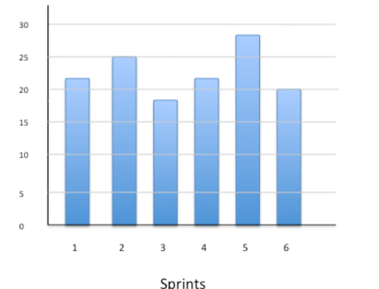

**How do we know the team’s velocity?**

* If the team is in place for some time, look at the history of the team’s velocity
* If the team is new, run couple of sprints to establish the initial velocity
* Use the average velocity over several sprints to predict the completion date

**Let’s plan a release**

Let’s say the release backlog of size 100 points. The team ran 4 sprints and had velocities of 8, 11, 9, 10

Average velocity for 4 sprints: 38/4 = 9.5

Best Velocity:11    |   Worst Velocity: 8

Remaining points after 4 sprints: 62 | Required sprints to complete 62 points (Round up value)

@ Average velocity: 62/9.5 = 7 sprints | @Best Velocity: 62/11 = 6 sprints | @ Worst Velocity: 62/8 = 8 sprints

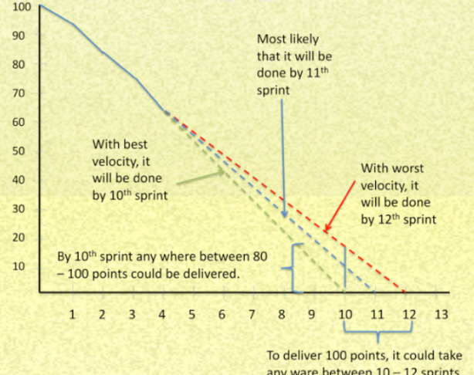

The **output** for release plans is: –

* Release scope/date
* Prioritized backlog
* Ordered estimated in size and forecasted in sprint, Release burnt chart

## Agile Framework Comparison

**Comparison of Scrum Vs XP**

|  |  |  |
| --- | --- | --- |
| **Definition** | **Scrum** | **Extreme Programming** |
| **Time Boxing**  (Fixed Length period of time) | Sprint | Iteration |
| **Release to Production** | Release | Small Release |
| **Agile Planning Meetings** | Sprint | Release Planning | Planning Game |
| **Business representative to Project** | Product Owner | Customer |
| **Lessons Learned style** | Retrospective | Reflection |
| **Agile Project Manager** | Scrum Master | Coach |
| **Empowered cross Functional team** | Development Team | Team |
| **Brief daily status meeting** | Daily Scrum | Daily Standup |

**Scrum Vs XP Vs Kanban**

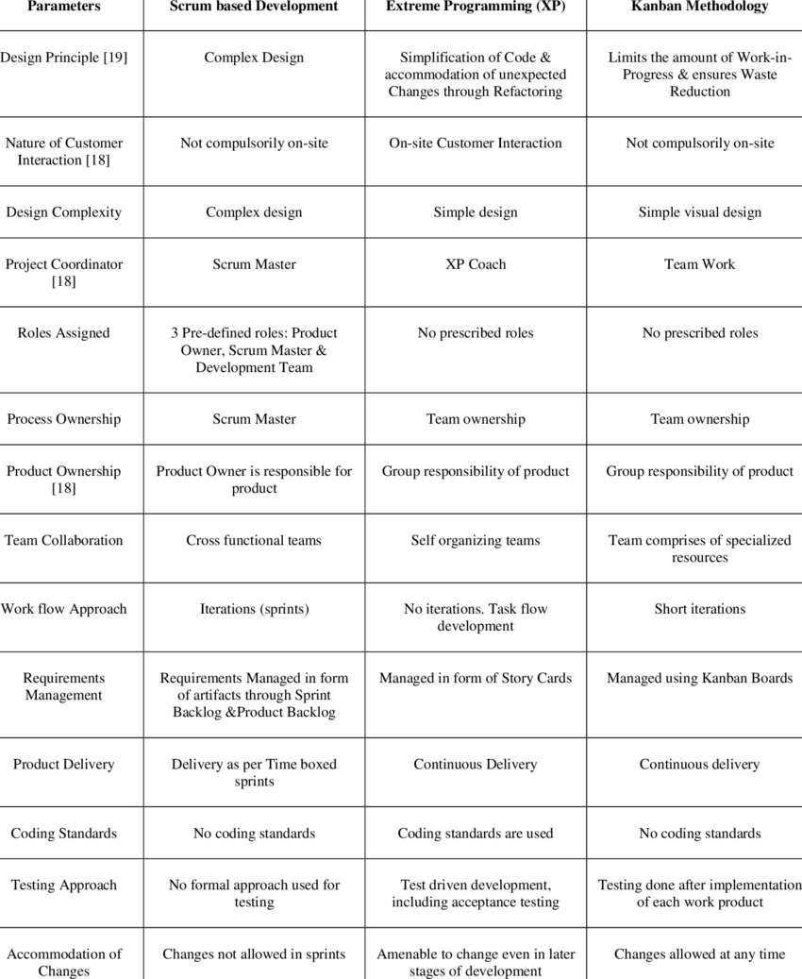

**Scrum Positive Challenges**

|  |  |
| --- | --- |
| **Scrum Positive** | **Scrum Challenges** |
| * Inspect | Adapt | Transparency * Fail fast | Faster feedback * Collective ownership * Continuous Improvement * Self-Organized team * Collaboration * Engagement * Self-Delivery Teams * Well defined roles / ceremonies * Early Feedback * Accountability * Shared risk * High Quality * Excellent Productivity | * Skill set for co-locations * Delivery commitment of every two weeks * Not having deliverable after every Sprint * Larger Team * Mind-set Change * Ad-hoc requirements within the Sprint * Resource Criticality * Inefficient resource utilization (Testers are free at the beginning and over busy at the end) * Adaptability & Sustainability * Time-box collaboration * Team level limit (Only for smaller teams) * Cross functional team structure * Framing Agile centric metrics * Some-times story point estimation |

**Kanban Positive Challenges**

|  |  |
| --- | --- |
| **Kanban Positive** | **Kanban Challenges** |
| * Supports dynamic requirements prioritization * No time-box value * Lead & cycle time delivery can be calculated * Visualize blockage through the cumulative flow diagram | workflow * Limit Work In Progress * Manage Workflow, Pull * Faster Throughput * No Team Limit, Allows Specialist * Well defined Roles * Improves [Kaizen] Process * Expose Bottleneck | * Knowledge work industry (Green –New Brown-Existing project) * Arriving optimum WIP limit * Lesser Collaboration * No Control limit on changes * Higher degree of variation * Starvation * New Product Development * Limited Estimation / Commitment |

**Scrum Vs Kanban**

|  |  |
| --- | --- |
| **Scrum** | **Kanban** |
| * Quicker Value Realization * Empower & Motivated Teams * Customer Satisfaction * Good Quality | * Better Visualization * Faster Throughput, Higher Cyclic Team * No Team limit, Allows Specialist Roles |

**Scrum Vs Kanban Vs Scrumban**

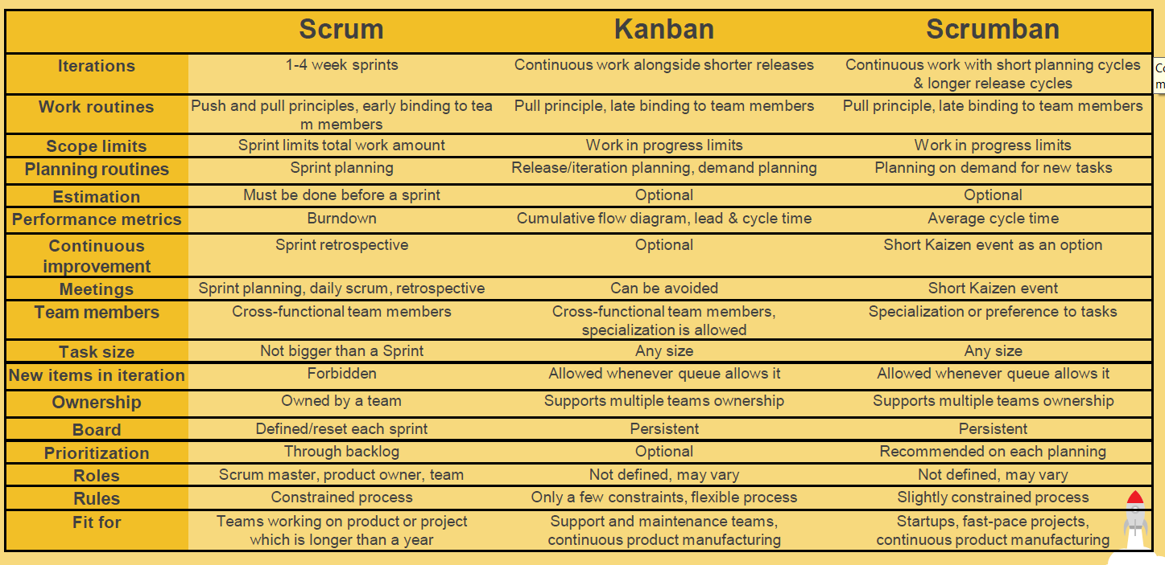

## Scrum Exercises

**Agile Intro – Exercise (Say True or False)**

1. Agile Manifesto suggests build everything that customer wants – **True**
2. Principle behind Agile Manifesto suggest emerging architecture –**True**
3. As per Agile Manifesto Architecture is not important but the functionality is – **False**
4. Agile Manifesto suggests defining and implementing architecture in first few iterations to enable teams to deliver working software in subsequent iterations – **False**
5. Scrum teams place value i planning but value responding to change even more –**True**
6. Scrum framework is good for projects, which are simple and predefined – **False**
7. According to Agile Manifesto, control and management is important – **False**
8. When Agile Manifesto suggests “Responding to change”, it means releasing products soon and often to test assumptions –**True**
9. Regular and frequent feedback is essential to address customer collaboration suggested by Agile Manifesto –**True**
10. Agile Manifesto suggests not to document anything but write code –**False**
11. Time boxing is one of the ways to maintain sustainable pace suggested by Agile principles – **True**
12. Any Process which exhibits transparency and helps the team to inspect and adapt based on evidence is called Empirical Process – **True**

**Scrum Roles – Exercise – 1 (Say True or False)**

**Product Owner**

1. Product Owner manages the release – **True**
2. Product Owner clarifies the requirement – **True**
3. Product Owner manages the tasks – **False** (Development Team takes care)
4. Product Owner tracks the progress in the sprint – **False**
5. Product Owner visits customers – **True**
6. Product Owner is responsible for maximizing the value of work done by the Scrum Team – **True**
7. Product Owner participates in daily scrum –**False**
8. Product Owner understands the competitors – **True**
9. Product Owner is available to team during the sprint – **True**
10. Product Owner decides how much work to do in the sprint – **True**
11. Product Owner defines the architecture – **False**
12. Product Owner understands how our product is used by the customers – **True**
13. Product Owner evangelizes the product within and outside of organization – **True**
14. Product Owner orders the product backlog – **True**
15. Product Owner maintains the product backlog – **True**
16. Product Owner envision is the product – **True**
17. Product Owner is responsible for the profitability of the product –**True**

**Scrum Master**

1. Scrum Master commits work to product owner – **False**
2. Scrum Master manages the progress in the sprint – **True**
3. Scrum Master’s product is a well-known working team – **True**
4. Scrum Master is NOT responsible for the schedule – **False**
5. Scrum Master needs to coach Product Owner – **False**
6. Scrum Master is a change agent for Scrum – **True**
7. Scrum Master needs to be the master of Scrum – **False**
8. Scrum Master works in full time – **False**
9. Scrum Master is the manager of the team – **False**
10. Scrum Master is responsible for solving the team’s problem – **True**
11. Scrum Master manages the dependency with other teams – **True**
12. Scrum Master helps team adopt engineering practices – **True**
13. Scrum Master manages the project – **False**
14. Scrum Master facilitates the Scrum meetings- **True**
15. Scrum Master is the interface towards outside the team – **False**

**Development Team**

1. Team owns and improves its process – **True**
2. Team decides the priority of the work – **False**
3. Team manages the dependency with other teams – **False**
4. Team sets its own direction – **True**
5. Team commits sprint goal –**True**
6. Team maintains product backlog – **False**
7. Team maintains sprint backlog – **True**
8. Team manages the tasks – **True**
9. Team updates the sprint Burn down chart – **True**
10. Team updates the release Burn down chart – **False**
11. Team decides the architecture and design – **True**
12. Team follows Scrum Master’s command – **False**
13. Team follows Product Owner’s command – **False**
14. Team is not allowed to have conversation with customers – **False**
15. Team does test – **True**
16. Team is responsible for getting done – **True**

**Scrum Roles Mapping**

A servant-leader for the Scrum Team!!!

Accountable for building the high value products!!  
Acts as a change agent that increases the productivity of the Scrum Team!!!  
Coaches the Development Team for self-organization and cross-functionality!!!  
Removes impediments to the Development Team’s progress!!!  
Details out the product backlog items appropriately!!  
Empowered to make decisions on how to build the product increment!  
Empowered to make decisions regarding the product backlog management to achieve the vision!!  
Ensures the Product Owner knows how to order the Product Backlog items to maximize value!!!  
Facilitates Scrum events as requested or needed!!!  
Finds and teaches techniques for effective Product Backlog management to Product Owner!!!  
Helps employees and stakeholders of the organization understand and enact Scrum and empirical product development!!!  
Helps engineering team in estimating the backlog items by clarifying backlog items!!  
Helps optimize the external interactions with the scrum team to maximize the value  
created!!!  
Helps product owner in backlog management by explaining technical constraints.  
Helps product owner prioritize the work. Teaches PO and stakeholders value  
based prioritization!!!  
Helps Product Owner understanding product planning in an empirical environment!!!  
Helps the Scrum Team understand the need for clear and concise Product Backlog items!!!  
Leads and coaches the organization in its Scrum adoption!!!  
Optimizes the value of the work the development team performs!!  
Participates in all Scrum events!  
Responsible for building the product fast by eliminating the waste!!!  
Responsible for creating and establishing the product vision!!  
Responsible for creating and managing the release plans!!  
Responsible for creating and managing the sprint backlog!  
Responsible for creating the product increment!  
Responsible for deciding whether to release the product increment or not!!  
Responsible for ensuring Scrum is understood and enacted!!!  
Responsible for identifying and eliminating “Technical Debt”!  
Responsible for implementing good engineering practices!  
Responsible for keeping the Product Backlog transparent, clear and visible to everyone!!  
Responsible for learning all the functions required to deliver a product increment!  
Responsible for managing the Product Backlog!!  
Responsible for ordering the backlog items to maximize the value delivery!!  
Responsible for the quality of the product increment!  
Responsible for tracking the progress of the sprint!  
Responsible for tracking the release progress!!  
Responsible for understanding and answering any question related to product domain!!  
Reviews the product increment and gives feedback to the development team!!

**Answers**

**Ends with! – Development Team | Ends with!! – Product Owner | Ends with!!! – SCRUM Master**

**Scrum Roles – Exercise - 2**

**Role Mapping**

Map the roles listed below to Scrum Roles based on the similarity in responsibilities and skills required

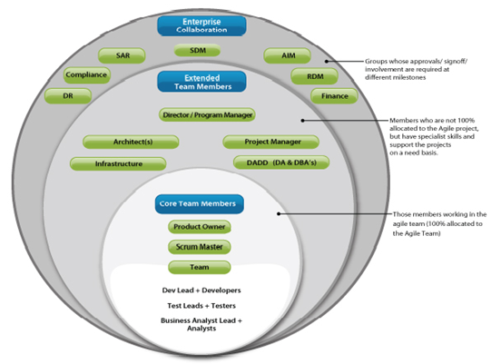

1. Product Manager – Product Owner
2. Product Marketing Manager – Product Owner
3. Test Engineer – Development Team
4. Programmer – Development Team
5. Technical Architect – Development Team
6. Build and Release Engineer – Development Team
7. Pre-sales – Product Owner
8. Technical Writer – Development Team
9. Project Manager – Other roles
10. Business Analyst – Development Team
11. User Experience Expert – Development Team
12. User Interface Specialist – Development Team

**Responsibility Mapping**

Map the roles listed below to Scrum Roles based on your understanding of Scrum so far

1. Facilitate Delivery – Scrum Master
2. Motivate Team – Scrum Master
3. Manage product release schedule – Product Owner
4. Manage Product Budget – Product Owner
5. Manager Product Scope – Product Owner
6. Manage release decisions – Product Owner
7. Identify and address systematic problems and address them – Scrum Master
8. Build learning team – Scrum Master
9. Estimate Work – Development Team
10. Provide technical solutions – Development Team
11. Remove Impediments – Scrum Master
12. Manage Product Risks – Product Owner
13. Manage Product dependencies – Product Owner
14. Conduct User Research – Development Team
15. Product Promotion – Product Owner
16. Product Positioning – Product Owner
17. Maximize team potential – Scrum Master

**Skill Mapping**

Map the roles listed below to Scrum Roles based on the responsibilities they need to perform.

1. System Thinking – Scrum Master
2. Decision Making – Product Owner
3. Product Marketing – Product Owner
4. Customer Empathy -Product Owner
5. Business Acumen -Product Owner
6. Technical Skills – Development Team
7. Domain knowledge – Product Owner
8. Process Expertise – Scrum Master
9. Leadership – Scrum Master
10. User Experience Skills – Product Owner
11. Product Discovery Skills – Product Owner
12. Stakeholder Management – Product Owner
13. Facilitation – Scrum Master
14. People Skills – Scrum Master
15. Coaching – Scrum Master
16. Process Expertise / Champion – Scrum Master
17. Collaboration – Scrum Master
18. Emotional Intelligence – Scrum Master
19. Team Building – Scrum Master

**Scrum Artifacts – Exercise**

**Say True or False**

**General**

1. Product Owner is responsible for establishing the product vision – **True**
2. Higher ordered Product Backlog Items are usually clearer and more detailed than lower ordered ones – **True**
3. Anyone can create Product Backlog Items, but the Product Owner has overall responsibility to manage it – **True**
4. Life of the Product backlog is same as life of the product itself – **False**
5. The Development team is responsible for estimating of backlog items – **True**
6. Product Backlog Refinement is the act of adding detail estimates, and order to items i n the Product Backlog – **True**
7. Team and PO decide the frequency and duration of the backlog refinement meeting. However, it is time boxed at 10% of total available time – **True**
8. Product Backlog Refinement is an Ongoing activity throughout a scrum project – True
9. Having a Product Backlog Refinement meeting helps sprint planning to go smoother – **True**
10. A single team works from multiple product backlogs – **False**
11. Product Owner keeps the product backlog somewhere secretly so that no one can touch it – **False**
12. The product backlog is sorted from small items (At Top) to large (At Bottom) – **False**
13. The product backlog should be updated only in backlog refinement meeting – **False**
14. In backlog refinement, the team goes through the entire backlog and refines it – **True**
15. Development team may work on critical engineering items without placing them in product backlog – **False**
16. Once the product backlog is created it is usually does not change – **False**
17. Scrum Master tells product owner what should be the priority in backlog refinement meeting – **False**
18. Once can item be placed in the product backlog, it is never re-ordered – **False**

**Product Backlog**

1. It is an ordered list of everything that might be needed in the product – **True**
2. It’s a single source of requirements for any changes to made the product – **True**
3. The Product Owner is responsible for the product backlog, including its content, availability, and ordering – **True**
4. A Product Backlog is never complete – **True**
5. As long as a product exists, its product backlog also exists – **True**
6. The defect should not be added to product backlog – **False**
7. Changes in business requirements, market conditions, or technology may cause changes in the product backlog – **True**
8. Multiple scrum teams can work together on the same product – **True**
9. Product Backlog items can be updated at any time by the product owner or at the product owner’s discretion – **True**
10. All the items in product backlog are comprehensively detailed – **False**
11. The Product Backlog Item should always be written in the form of a User Story – **False**

**Sprint Backlog**

1. The Sprint Backlog is a forecast by the Development Team about what functionality will be in the next increment – **True**
2. The Development Team modifies the Sprint Backlog throughout the Sprint, and the Sprint Backlog emerges during the Sprint – **True**
3. Sprint Backlog is just a list of tasks to be completed during the sprint – **True**
4. Development team should pull stories in the order of priorities set by PO – **True**
5. Only the Development team can change its Sprint Backlog during a sprint – **True**
6. By tracking the remaining work throughout the Sprint, the Development Team can manage its progress- **True**
7. Sprint Backlog is used by the team to manage their hours – **True**
8. The main purpose of sprint Backlog is for the team to manage themselves – **True**
9. Sprint Backlog is for Product Owner to understand what the team has committed for the sprint – **True**
10. Sprint Backlog does not contain plan for delivering the product Increment and realizing the Sprint Goal – **True**

**Product Increment**

1. The increment is the sum of all the Product Backlog items completed during a Sprint and the value of the increments of all previous Sprints **– True**
2. At the end of a Sprint, the new increment must be “Done”, which means it must be in useable conditions and meet the Scrum Team’s Definition of Done” **– True**
3. Development team is responsible for producing product increment **– True**
4. Product Increment is “Done”. Only when stakeholders accept the stories in Sprint Review **– True**
5. Product Increment is always ready to be deployed at customer site **– True**
6. Engineering practices like TDD, continuous integration, pair programming improve the quality of Product increment**– True**
7. Velocity is the measure of how much valuable work that a team can do in a Sprint. **– True**
8. One of the ways to determine it is to sum up the story points associated with Product Backlog Items that are part of the Product Increment at the end of the Sprint – **True**
9. Product Owner guides team how to produce the Product Increment**– True**

**Product Backlog Refinement**

1. It’s best practice to hold Backlog Refinement at least once per Sprint – **True**
2. The duration of the Backlog Refinement meeting is 2 hours per Sprint – **False**
3. It’s the act of adding details, estimates and order PBI’s – **True**
4. It’s an ongoing collaboration between the Product Owner and the development team – **True**
5. It’s a part time activity during the Sprint. How and when is decided by the Scrum Team – **True**
6. PBI is always estimated in hours in Backlog refinement meeting – **False**
7. Backlog Refinement is requirement to keep the Product Backlog DEEP for at least 2 Sprints- **False**
8. The focus of the Backlog Refinement is future release – **False**
9. Backlog Refinement is also known as Story Time, Backlog grooming ad user Story Workshop – **True**
10. Development Team is responsible for all estimates – **True**
11. The Product Owner may influence the Development Team by helping it understand and select trade-offs, but the people who will perform the work make the final estimate – **True**
12. The PBI’s once estimated are never reviewed and revised during Backlog Refinement – **False**

**Scrum Meetings – Exercise 1**

**Say True or False**

What did you do yesterday? What will you do today? And which team members do you need to talk to? are the three questions of a daily scrum (**FALSE**)

Scrum Master should use the Daily Scrum to solve any impediments the team raises (**FALSE**)

Product Owner is not allowed to talk during the Daily Scrum (**TRUE**)

Main purpose of the Daily Scrum is to inspect the previous day’s work and plan for the next day (**TRUE**)

Daily Scrum is a good way for the Scrum Master to secretly micro-manage the team (**FALSE**)  
If the team is talking about a critical issue in daily scrum, the meeting could be  
extended until the discussion is completed (**FALSE**)

Daily Scrum is time boxed to 15 minutes (**TRUE**)

The purpose of the Sprint Review is to get feedback on what the team has accomplished during the sprint (**TRUE**)

Though Product owner calls few key stakeholders to Sprint Review, anyone who is interested can go (**TRUE**)

In the Sprint Review, team gives a power point presentation on what they worked on in the sprint (**FALSE**)

Sprint Review is the meeting where User Acceptance Testing is performed (**FALSE**)

In Sprint Review, Scrum Team discusses the current state of the product backlog and future direction for the product (**TRUE**)

At the end of the Sprint Review, release plan is updated if needed (**TRUE**)

Product Owner should wait till sprint review to give any feedback to the development team (**FALSE**)

Any feedback in Sprint Review that turns into new backlog item should be maintained in a separate backlog (**FALSE**)

Sprint Retrospectives should be held only at the end of the last sprint in a project or release (**FALSE**)

Sprint Retrospective is the place for scrum master to do the post mortem of the sprint (**FALSE**)

The Scrum Master participates as a peer team member in the sprint retrospective meeting from the accountability over the Scrum process (**TRUE**)

Scrum Master should create a safe environment for the team so that they will open up in Sprint Retrospective (**TRUE**)

Executives can also attend the Sprint Retrospective to know team’s problems (**FALSE**)  
Team should only inspect and adapt in retrospective and shouldn’t think about it rest of the time (**FALSE**)  
At the end of the Sprint Retrospective, major improvements are identified and an action plan to is created (**TRUE**)

The main theme of the Sprint Retrospective is to answer “How can we get better as a team?” (**TRUE**)

Sprint Planning is time boxed to 8 hours for 4 weeks sprint, but most teams try to get done in about half as long (**TRUE**)

Tasks in the Sprint Backlog are estimated collaboratively by the team even though one person will do the task (**TRUE**)

During the Sprint Planning meeting, the Scrum Master assigns tasks to individual team members (**FALSE**)

During the Sprint Planning, the Product Owner decides what items should be implemented in the sprint (**FALSE**)

Main purpose of the Sprint Planning is to come up with the forecast for the sprint (**TRUE**)

One of the main topics of the Sprint Planning is Product Owner explaining the details of the items (**TRUE**)

Team talks about possible solutions, high level design, automation strategy etc., during the Sprint Planning (**TRUE**)

Scrum Master comes up with the Sprint Goal at the end of the Sprint Planning (**FALSE**)

**Scrum Meetings – Exercise 2**

**Say true / false**

**The Sprint**

1. It’s a time-box of one month or less **– True**
2. Sprint length varies from Sprint to Sprint based on the PBI’s selected for the Sprint**– True**
3. Sprint is done when all the committed PBI’s meet definition of Done **– True**
4. Sprint Length is decided based on the size of the team **– True**
5. Sprint Length is decided based on how soon the Development team can deliver **– True**
6. Working product and how often the requirement changes **– True**
7. During first sprint, the Team works on architecture and plan for the rest of the Sprint **– True**
8. The team works on accomplishing the Sprint goal irrespective of whether its first or last Sprint **– True**
9. No changes are allowed to Sprint Goal, Length and Team during the Sprint **– True**
10. The Scope of the Sprint can’t be reorganized between the team and PO **– True**
11. The Sprint can be cancelled before the Sprint Time Box is over **– True**
12. None of the Work done in a cancelled Sprint is accepted **– True**

**Sprint Planning**

1. The team can proceed with Sprint Planning without Product Owner **– True**
2. The PO presents his/ her wish list and team asks questions to understand what needs to be built **– True**
3. While estimating PBI size in Sprint Planning is technically allowed, it’s best to estimate prior to planning **– True**
4. The Product owner assigns development tasks to the team in Sprint Planning **– True**
5. The Product Owner gets involved in figuring out how code is written **– True**
6. The Team may split the PBI’s in to tasks and estimate them in hours **– True**
7. The Team can commit to Sprint Goal based on either velocity or capacity **– True**
8. The Sprint Planning for a 2-week Sprint should be time-boxed to 4 hours **– True**
9. Adding a Backlog Refinement session half way through your sprint can help with making Sprint Planning shorter and more effective **– True**
10. During Sprint Planning, PO decides how many stories will be delivered by the end of the Sprint **– True**
11. The Scrum Team is responsible for crafting the Sprint Goal **– True**

**Daily Scrum**

1. It’s fine for the Daily Scrum to last up to 45 minutes **– True**
2. People from outside the team may attend, provided it’s okay with the team and they don’t interfere **– True**
3. The main purpose of Daily Scrum is to inspect where the team stands with respect to Sprint Goal and adapt its plan to get there **– True**
4. The Daily Scrum is a status update meeting for the Product Owner **– True**
5. The Participation of Product Owner in Daily Scrum is decided by the Team **– True**
6. Discussions of how to resolve issues should be done during a sidebar after the Daily Scrum **– True**
7. While PO is optional for DSM, PO can attend to see the progress being made and determine if team needs help **– True**
8. It’s helpful for the Daily Scrum to be in the same location, at the same time every day **– True**
9. Managers should attend the Daily Scrum to help ensure everyone is doing enough work **– True**
10. The Daily Scrum should not start until all participant arrive **– False**
11. If a team member is consistently late for the Daily Scrum, the Scrum Master should talk to the team member to figure out next course of action **– True**
12. The Sprint Burndown Chart should be updated in the Daily Scrum **– True**
13. The Team members should use only Daily Scrum to communicate impediments **– True**

**Sprint Review**

1. It’s expected that a team will demo a feature even if they did not finish it in the Sprint **– True**
2. The main purpose of the Sprint Review is for the Product Owner to accept the work done by the team **– True**
3. The main purpose of Sprint Review is for the Stakeholders to review the work done by the team and provide feedback **– True**
4. A PBI accepted by PO during the Sprint remains accepted even if the stakeholders disagree **– True**
5. Comments from stakeholders on accepted PBI’s might result in a new PBI that will be added to Product Backlog **– True**
6. Team should spend at least 4 hours preparing for the review, and the review should include power point slides **– True**
7. If the team cannot demo a feature because it was not completed, it’s okay for a manager to question the team’s approach in this meeting **– True**
8. The Sprint Review is mainly for show and has little impact on the product **– True**
9. The Sprint Review is one of the ways in which the SCRUM address customer collaboration **– True**
10. The Sprint Review helps team in responding to change better as the assumptions will be tested here **– True**
11. A manager should pick who does the demos during the Sprint Review **– True**
12. Feedback from stakeholders during the Sprint Review should be collected and put on the backlog for consideration by the Product Owner instead of spawning long conversations during the review **– True**

13. The Product Owner discuss how the Product Backlog stands at the moment and projected dates of completion during the Sprint Review **– True**

## Scrum Games

**Ball Game**

Team must have 5 balls in the cup; One by one has to move the ball in hand from one person hand to another without any slippage. Ball should touch the hands of every team member to get 1 point.

Finally, it reaches the Project Manager and finally reaches the Program Manager. Next Program Manager will share the ball to the respective team. There must be air time for the ball while moving between the hands. The ultimate goal is to make many points at a given time. Each and every round the points get increased for each and every team.

In last round (5th) the Project manager is moved, so team can give the ball and take the ball in round with Program Manager only to remove the dependency of Project Manager.

The specifications are: - Time Boxed: 2 Mins for 5 rounds

**Moral:** Be Courageous and Resolve the problems with problem domains (Simple |Complicated | Complex | Chaotic) **Collaboration** is more important

In **Round 1 -4**, performance will gradually increase, more pressure to extract more work, need more educated people needed with variety of skills

In **Round 5**, team is more optimized to remove the bottleneck, the main advantage is 1) external dependency is removed, 2) Build the product incrementally 3) Work with hyper productive team

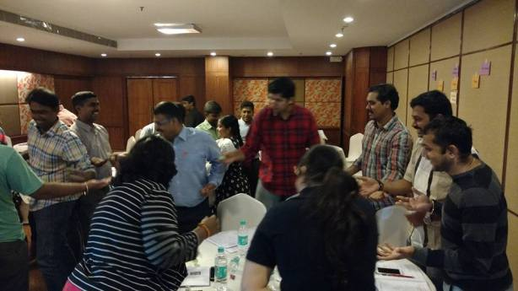

**Zen Fly Project**

Design a Zen Fly Project for the child with safety measures. The specifications are:-

* Time Boxed: 2 Mins
* 7 Planes should deliver
* Plane should have logo and as well as name
* Wings should be colored
* Plane should fly at least 4 Meter distance

**Moral:** Scrum Value Improvement – Focus towards goal achievement



**Hands Push**

Push the hand with one of your team mates. The specifications are:-

* Time Boxed: 2 Mins
* If one team member pushes, another team member has to manage, vice versa
* Both can push and move across

**Moral:** Scrum Value Improvement – Focus, Courage, Openness, Commitment and Respect to the team members



**Hands Untangle with entire Team**

Entire team can untangle with each other

**Moral:** **Collaboration** Makes Success



**Chinese Whisper**

User communication over a story, if one team member communicates the story by action , next team member can understand first and repeat the action by his/her own understanding and convey to another team member vice versa..

**Moral:** **Communication get diluted or lost** because original message was not conveyed properly to end user from the Customer.



**Planning Poker**

During Agile estimation, use poker card to raise the points as per the baseline.



**Moral:** Development Team **right and uniform decision** makes the project successful.

## Scrum Master Certifications Topics

|  |  |
| --- | --- |
| **Certified Scrum Master**   * Agile and Scrum overview * The three roles in Scrum * Scrum ceremonies * Scrum artifacts * Sprint execution * Daily Scrum * Sprint retrospective * Definition of Done * Acceptance criteria * Definition of Ready * Release planning * Sprint burndown chart * Release burn-up chart * Product planning * User stories * Agile estimation * Planning poker | **Advanced Certified Scrum Master**   * Agile Coaching Concepts * Agile Facilitation * Deeper Dive into Lean, Agile and Scrum * Services to Development Team * Services to Product Owner * Services to Organization * Personal Development |